Tenth Sunday after Pentecost
August 2, 2026

Gathering
Welcome & Announcements
Prelude
Confession and Forgiveness
In the name of the Father, and of the Son, and of the Holy Spirit.
Amen.
Almighty God, to whom all hearts are open, all desires known, and from whom no secrets are hid: Cleanse the… through Jesus Christ our Lord.
Amen
If we say we have no sin… cleanse us from all unrighteousness.
Most merciful God,
We confess that we are slaves to sin and cannot free ourselves. We have sinned against you in thought, word, and deed, by what we have done and by what we have left undone. On account of your great mercy, through your Son Jesus Christ, we pray that you would free us from ourselves, so that we may trust in your promise and obey your commandments, to the glory of your holy name. Amen.
Absolution -
Almighty God in His mercy…… In the Name of the Father, Son and Holy Spirit. Amen.

Gathering Hymn Lord, Whose Love is Humble Service ELW #712

L: The grace of our Lord Jesus Christ, the love of God, and the communion of the Holy Spirit be with you all.
C: And also with you.
L: O give thanks to the LORD, for he is good,
C: for his steadfast love endures forever.
L: O give thanks to the God of heaven,
C: for his steadfast love endures forever.

Psalm 136: 1, 26

Praise Hymn I Love to Tell the Story ELW # 661

Greeting and Prayer of the Day
Almighty, eternal God,
your kindness is far more than we desire or deserve. Generously pour out your mercy to forgive where our conscience is afraid and to provide that for which by ourselves, we do not even presume to pray; through Jesus Christ, your Son, our Lord, who lives and reigns with you and the Holy Spirit, one God, now and forever. Amen
Word
First Reading Isaiah 55:1-5 OT p. 760-761
Second Reading Romans 9:1-16 NT p. 161-162
Gospel Verse Halle, Halle, Hallelujah ELW #172
Gospel Matthew 14: 13-21 NT p. 16
Chidren’s Time
Sermon Heart of the Gospel: Tough Talk
Hymn of the Day There’s a Wideness in God’s Mercy ELW # 587
Prayers L: God of grace. All: Hear our prayer.
Sharing of the Peace
The peace of Christ be with you always! And also with you.
Meal
Gathering of Offerings (including change for our mission church)

Offertory Hymn We Come to the Hungry Feast ELW # 479
Offertory Prayer
P: Let us pray. Merciful Father,
C: we offer with joy and thanksgiving what you have first
given us—our selves, our time, and our possessions, signs of
your gracious love. Receive them for the sake of him who
offered himself for us, Jesus Christ our Lord. Amen
Words of Institution
Lord’s Prayer
Distribution — All are welcome! We will commune by tables around the altar. For those who prefer, gluten-free wafers and grape juice are offered. Children are invited to come forward to receive a blessing.
Post Communion Prayer
Let us pray…We give you thanks, almighty God, that you have refreshed us through the healing power of this gift of life; and we pray that in your mercy you would strengthen us, through this gift, in faith toward you and in fervent love toward one another; for the sake of Jesus Christ our Lord. Amen
Sending
Benediction
Sending Hymn Take My Life, That I May Be ELW # 583
Dismissal Go in peace. Christ is near. All: Thanks be to God!
Preacher: Pastor Carl Billings
Musician: Carol Kelm
Ushers: Ned Hahn
Altar Guild: Joan Bartz
This Week at Holy Cross
Today 9:00 am — Worship
10:10 am — Fellowship (Council Serving)

Monday 11:00 am — Bible Study at Havenwood
4:00 pm — Sundaes on Mondays 4-4:30
6:00 pm — Faith & Life / FUN Meeting

Tuesday-Thursday – 5:30-7:30 pm Building Rental Blue Thunder

Friday 9:30 am — Friday Morning Coffee

Next Sunday,
August 9th 9:00 am — Worship
10:10 am — Fellowship (WOW Serving)

Blood Mobile – Monday August 10th the Blood Mobile will be at Holy Cross. Sign up sheet for volunteer workers is on the kiosk in the lobby.
Sign up to donate blood at www.redcrossblood.org.

Outdoor Worship & Blessing of the Backpacks – Sunday August 23rd we will be worshiping outdoors at Himan Park. We will also be doing Blessing of the Backpacks so have the kids bring their backpacks.

LCMC Annual Gathering – October 4-7, 2026. Lutheran Church of Hope in West Des Moines IA, registration by July 31, 2026. www.lcmc.net

Ceiba Vida International-Guatemalan Girls School – Change Offering — Our mission is to provide young girls an excellent and challenging educational experience modeling Christ’s love.

Prayer Request/Connection Card—Please find new green Connection Card/Prayer Request cards in the pews in front of the bibles. Please fill out as needed and place in collection plate.

Pastor Carl Billings in Glenwood City –
Tuesday– Afternoon – evening, & Wednesday all day

Thursday – Morning, Sunday – Morning
GIVING with VANCO
Wanda will be in the office – Monday-Wednesday 9-3 or so…
Church Office Closed Thursday Aug 8th, Wanda is out of town.

Holy Cross Lutheran Church
615 Maple Street, PO Box 65, Glenwood City, WI 54013
(715) 265-4411 gcHolyCross@cltcomm.net gcholycross.org
Intentional Interim Pastor Carl Billings
Phone: (763) 360-7126 Email: carlbillings@me.com

August 2, 2026
Tenth Sunday after Pentecost

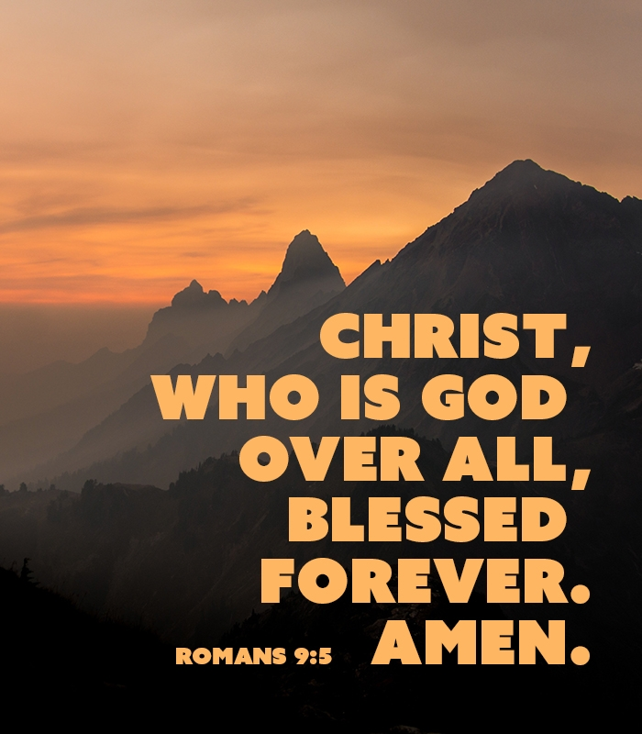

Holy Cross Lutheran Church

Called by the Holy Spirit
to Come
to Grow
to Live
as Disciples of Jesus Christ

