Second Sunday after Pentecost
June 7, 2026

Gathering
Welcome & Announcements
Prelude
Confession and Forgiveness
In the name of the Father, and of the Son, and of the Holy Spirit.
Amen.
Almighty God, to whom all hearts are open, all desires known, and from whom no secrets are hid: Cleanse the… through Jesus Christ our Lord.
Amen
If we say we have no sin… cleanse us from all unrighteousness.
Most merciful God,
We confess that we are slaves to sin and cannot free ourselves. We have sinned against you in thought, word, and deed, by what we have done and by what we have left undone. On account of your great mercy, through your Son Jesus Christ, we pray that you would free us from ourselves, so that we may trust in your promise and obey your commandments, to the glory of your holy name. Amen.
Absolution -
Almighty God in His mercy…… In the Name of the Father, Son and Holy Spirit. Amen.

Gathering Hymn Lead On, O King Eternal ELW #805

L: The grace of our Lord Jesus Christ, the love of God, and the communion of the Holy Spirit be with you all.
C: And also with you.
L: You have dealt well with your servant,
C: O LORD, according to your word.
L: Teach me good judgment and knowledge,
C: for I believe in your commandments.
L: Before I was humbled I went astray,
C: but now I keep your word.
L: You are good and do good;
C: teach me your statutes.

Psalm 119:65-72
Praise Hymn Here I Am, Lord ELW #574

Greeting and Prayer of the Day
O God,
you are the protector of all who trust in you, and beside you, nothing is strong or holy. Multiply your mercy and guide us that while using the good things of this fleeting life, we do not lose hold of the things that endure forever. Grant this, we pray, through Jesus Christ, your Son, our Lord, who lives and reigns with you and the Holy Spirit, one God, now and forever. Amen
Word
First Reading Hosea 5:15-6:6 OT p. 934
Second Reading Romans 4:13-25 NT p. 162-162
Gospel Verse God Is Here! ELW #526 vs. 1 Gospel Matthew 9:9-13 NT p. 9
Chidren’s Time
Sermon Heart of the Gospel: As Good As Dead

Hymn of the Day Love Divine, All Loves Excelling ELW #631

Prayers L: God of grace. All: Hear our prayer.

Sharing of the Peace
The peace of Christ be with you always! And also with you.

Meal
Gathering of Offerings (including change for our mission church)

Offertory Hymn Thine the Amen ELW #826 vs 1

Offertory Prayer
Words of Institution
Lord’s Prayer
Distribution — All are welcome! We will commune by tables around the altar. For those who prefer, gluten-free wafers and grape juice are offered. Children are invited to come forward to receive a blessing.
Post Communion Prayer
Let us pray…We give you thanks, almighty God, that you have refreshed us through the healing power of this gift of life; and we pray that in your mercy you would strengthen us, through this gift, in faith toward you and in fervent love toward one another; for the sake of Jesus Christ our Lord. Amen

Sending
Benediction
Sending Hymn Will You Come and Follow Me ELW #798
Dismissal Go in peace. Christ is near. All: Thanks be to God!
Preacher: Pastor Carl Billings
Musician: Carol Kelm
Ushers: Luanne Flick
Altar Guild: Luanne Flick
This Week at Holy Cross
Today 9:00 am — Worship
10:10 am — Fellowship (Council Serving)

Monday 11:00 am — Bible Study at Havenwood
6:00 pm — Resources Meeting
7:00 pm — Council Meeting

Tuesday 6:00 pm — Threads of God’s Love

Thursday 10:30 am — Glenhaven Worship

Friday 9:30 am — Friday Morning Coffee

Next Sunday,
June 14 9:00 am — Worship
10:10 am — Fellowship (WOW Serving)

Donuts with Dad – Join us Father’s Day June 21st following worship for DONUTS and breakfast with dad. All are welcome! See insert

Community VBS —This year’s Vacation Bible School will be
July 27-30, 6 pm to 8 pm hosted by Holy Cross. See insert

Fair Stand – St Croix County Fair July 15 – 19, will be here before we know it! Watch for details on how you can help .

Ceiba Vida International-Guatemalan Girls School – Change Offering — Our mission is to provide young girls an excellent and challenging educational experience modeling Christ’s love.

LCMC Annual Gathering – October 4-7, 2026. Lutheran Church of Hope in West Des Moines IA, registration by July 31, 2026.
Please reach out to April Goodwin if you would like to attend. Church will pay for the first 2 people going. Visit www.lcmc.net for full details.

Pastor Carl Billings in Glenwood City –
Tuesday– Afternoon – evening, & Wednesday all day

Thursday – Morning, Sunday – Morning
GIVING with VANCO
Wanda will be in the office – Monday-Thursday 9-3 or so…

Holy Cross Lutheran Church
615 Maple Street, PO Box 65, Glenwood City, WI 54013
(715) 265-4411 gcHolyCross@cltcomm.net gcholycross.org
Intentional Interim Pastor Carl Billings
Phone: (763) 360-7126 Email: carlbillings@me.com

June 7, 2026
Second Sunday after Pentecost

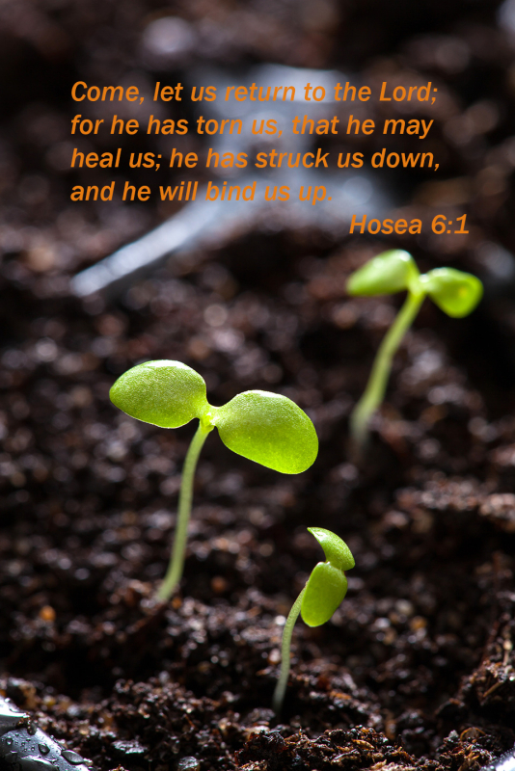

Holy Cross Lutheran Church

Called by the Holy Spirit
to Come
to Grow
to Live
as Disciples of Jesus Christ

