Third Sunday after Pentecost
June 14, 2026

Gathering

Welcome & Announcements
Prelude

Confession and Forgiveness
In the name of the Father, and of the Son, and of the Holy Spirit.
Amen.
Almighty God, to whom all hearts are open, all desires known, and from whom no secrets are hid: Cleanse the thoughts of our hearts by the inspiration of your Holy Spirit, that we may perfectly love you and worthily magnify your holy name, through Jesus Christ our Lord.
Amen
If we say we have no sin… cleanse us from all unrighteousness.
Most merciful God,
We confess that we are slaves to sin and cannot free ourselves. We have sinned against you in thought, word, and deed, by what we have done and by what we have left undone. On account of your great mercy, through your Son Jesus Christ, we pray that you would free us from ourselves, so that we may trust in your promise and obey your commandments, to the glory of your holy name. Amen.
Absolution -
Almighty God in His mercy…… children of God and bestows on them the Holy Spirit. Amen.

Gathering Hymn Savior, like a Shephard Lead Us ELW #789

L: The grace of our Lord Jesus Christ, the love of God, and the communion of the Holy Spirit be with you all.
C: And also with you.
L: Make a joyful noise to the LORD, all the earth.
C: Worship the LORD with gladness; come into his presence
with singing.
L: Know that the LORD is God. It is he that made us, and we are his; we
are his people, and the sheep of his pasture.
C: Enter his gates with thanksgiving, and his courts with
praise. Give thanks to him, bless his name.
L: For the LORD is good; his steadfast love endures forever, and his
faithfulness to all generations.

Psalm 100:1-5

Praise Hymn God of the Sparrow ELW #740
Greeting and Prayer of the Day
O Lord,
our God, arrange the course of this world that peace may come and your tranquil Church rejoice through greater service. Grant this, we pray, through Jesus Christ, your Son, our Lord. He lives and reigns with you and the Holy Spirit, one God, now and forever. Amen
Word
First Reading Exodus 19:2-8a OT p. 72
Second Reading Romans 5:6-15 NT p.162
Gospel Verse Listen, God Is Calling ELW #513 vs.1
Gospel John 14:15-21 NT p. 113
Children’s Time
Sermon Heart of the Gospel: Dad Will Fix It
Hymn of the Day Take My Life, That I May Be ELW # 685 vs.1-3

Apostle’s Creed ELW p.105

Prayers L:God of grace. All: Hear our prayer.
Lord’s Prayer

Sharing of the Peace
The peace of Christ be with you always! And also with you.

Thanksgiving
Gathering of Offerings (including change for our mission church)

Offertory Hymn Take My Life, That I May Be ELW # 685 vs.4-6
Offertory Prayer
P: Let us pray. Merciful Father,
C: we offer with joy and thanksgiving what you have first
given us—our selves, our time, and our possessions, signs of
your gracious love. Receive them for the sake of him who
offered himself for us, Jesus Christ our Lord. Amen
Sending
Benediction
Sending Hymn Sent Forth by God’s Blessing ELW #547
Dismissal Go in peace. Live by the Spirit All: Thanks be to God!
Preacher: Pastor Carl Billings
Musician: Carol Kelm
Ushers: Lanne Flick
Altar Guild: Luanne Flick
This Week at Holy Cross
Today 9:00 am — Worship
10:10 am — Fellowship (WOW Serving)

Monday 11:00 am — Bible Study at Havenwood

Wednesday 10:00 am — WOW Bingo at Glenhaven
9am-4pm — Building Rental Fellowship Hall - WestCap

Thursday 11am-noon — StCroix Food Pantry Truck in back parking
NEWSLETTER ARTICLE DEADLINE

Friday 9:30 am — Friday Morning Coffee

Next Sunday,
June 21st 9:00 am — Worship – Father’s Day
10:10 am — Donuts with Dad’s w/breakfast

Congregational Meeting Sunday June 28th 10:00 – The purpose of this meeting is to provide information and hold a vote regarding the purchase and installation of video recording equipment for our church.

Donuts with Dad – Join us next Sunday Father’s Day June 21st following worship for DONUTS and breakfast with dad. All are welcome! See insert

Community VBS —This year’s Vacation Bible School will be
July 27-30, 6 pm to 8 pm hosted by Holy Cross. See insert

Fair Stand – St Croix County Fair July 15 – 19, will be here before we know it! Watch for details on how you can help .

LCMC Annual Gathering – October 4-7, 2026. Lutheran Church of Hope in West Des Moines IA, registration by July 31, 2026.
Visit www.lcmc.net for full details.

Newsletter Article Deadline – Articles for the July Newsletter are due in the office by Thursday June 18.

Address Change – Beradene “Berdie” Olson – Park Place North
220 N Lockwood Street Apt #255, Woodville, WI 54028

Pastor Carl Billings in Glenwood City –
Tuesday– Afternoon – evening, & Wednesday all day
Thursday – Morning, Sunday – Morning

Wanda will be in the office Monday-Thursday 9-3 or so…
GIVING with
VANCO
Holy Cross Lutheran Church
615 Maple Street, PO Box 65, Glenwood City, WI 54013
(715) 265-4411 gcHolyCross@cltcomm.net gcholycross.org
Intentional Interim Pastor Carl Billings
Phone: (763) 360-7126 Email: carlbillings@me.com

June 14, 2026
Third Sunday after Pentecost

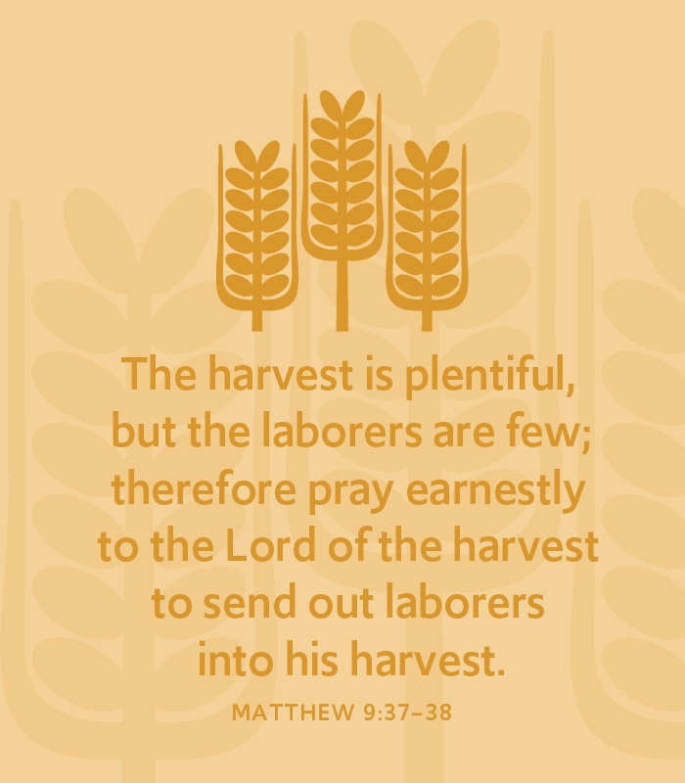

Holy Cross Lutheran Church

Called by the Holy Spirit
to Come
to Grow
to Live
as Disciples of Jesus Christ

