The Holy Trinity
May 31, 2026

Gathering
Welcome & Announcements
Prelude

Confession and Forgiveness
In the name of the Father, and of the Son, and of the Holy Spirit.
Amen.
Almighty God, to whom all hearts are open, all desires known, and from whom no secrets are hid: Cleanse the thoughts of our hearts by the inspiration of your Holy Spirit, that we may perfectly love you and worthily magnify your holy name, through Jesus Christ our Lord.
Amen
If we say we have no sin, we deceive ourselves, and the truth is not in us. But if we confess our sins, God who is faithful and just will forgive our sins and cleanse us from all unrighteousness.
Most merciful God,
We confess that we are slaves to sin and cannot free ourselves. We have sinned against you in thought, word, and deed, by what we have done and by what we have left undone. On account of your great mercy, through your Son Jesus Christ, we pray that you would free us from ourselves, so that we may trust in your promise and obey your commandments, to the glory of your holy name. Amen.
Absolution -
Almighty God in His mercy…… Father, Son and the Holy Spirit. Amen.

Gathering Song Song over the waters W & P # 127 vs.1,3,4

L: The grace of our Lord Jesus Christ, the love of God, and the communion of the Holy Spirit be with you all.
C: And also with you.
L: LORD, our Lord, how majestic is your name in all the earth!
C: You have set your glory in the heavens.
L: Through the praise of children and infants you have established a stronghold against your enemies,
C: to silence the foe and the avenger.
L When I consider your heavens, the work of your fingers,
C: the moon and the stars, which you have set in place,
L: what is mankind that you are mindful of them,
C: human beings that you care for them?
L: You have made them a little lower than the angels

C: and crowned them with glory and honor.
L: You made them rulers over the works of your hands;
C: you put everything under their feet:
L: all flocks and herds,
C: and the animals of the wild,
L; the birds in the sky, and the fish in the sea,
C: all that swim the paths of the seas.
L: LORD, our Lord,
C: how majestic is your name in all the earth!
Psalm 8:1-9
Praise Song Spirit Song W & P #130
Greeting and Prayer of the Day
Almighty and everlasting God,
you have given us grace to make the confession of a true faith. We acknowledge your glorious eternal Trinity, and we adore the unity of your majestic work. Defend us by this faith from all adversity and opposition to your way; through Jesus Christ, your Son, our Lord, who lives and reigns with you and the Holy Spirit, one God, now and forever. Amen
Word
First Reading Genesis 1:1-2:4a OT p. 1-2
Second Reading Acts 2:14a, 22-36 NT p.123-124
Gospel Verse Change my heart, O God W & P #28
Gospel Matthew 28:16-20 NT p. 34
Children’s Time
Sermon Go: Get Off the Mountain
Song of the Day Let justice roll like a river W & P #85 vs.1,2,5
Prayers L: God of grace. All: Hear our prayer.
Sharing of the Peace
The peace of Christ be with you always! And also with you.
Meal
Gathering of Offerings (including change for our mission church)
Offertory Song Holy, holy holy W & P #62 2X
Offertory Prayer
P: Let us pray. Merciful Father,
C: we offer with joy and thanksgiving what you have first
given us—our selves, our time, and our possessions, signs of
your gracious love. Receive them for the sake of him who
offered himself for us, Jesus Christ our Lord. Amen
Words of Institution
Lord’s Prayer
Continued ->
Distribution — All are welcome! We will commune by tables around the altar. For those who prefer, gluten-free wafers and grape juice are offered. Children are invited to come forward to receive a blessing.
Post Communion Prayer
Sending
Benediction
Sending Song Go make disciples W & P #47
Dismissal Go in peace. Live by the Spirit All: Thanks be to God!

Preacher: Pastor Carl Billings
Musicians: Carol Kelm, Bruce Kelm
Ushers: Tom & Nancy Stack
Altar Guild: Gloria Hill
This Week at Holy Cross
Today 9:00 am — Worship
10:10 am — Fellowship (WOW Serving)
10:15 am — Property Management Team Meeting

Monday 11:00 am — Bible Study at Havenwood
6:30 pm — F & L / FUN Meeting
Next Sunday,
June 7 9:00 am — Worship
10:10 am — Fellowship (Council Serving)
Community VBS —This year’s Vacation Bible School will be
July 27-30, 6 pm to 8 pm hosted by Holy Cross. We are thrilled to welcome Immanuel Lutheran Church in addition to long- time friend St. John the Baptist Catholic Church. Our theme is True North!
Many hands will be needed to make this all happen.

Fair Stand – St Croix County Fair July 15 – 19, will be here before we know it! Watch for details on how you can help .

Ceiba Vida International-Guatemalan Girls School – Change Offering — Our mission is to provide young girls an excellent and challenging educational experience modeling Christ’s love.


Pastor Carl Billings in Glenwood City –
GIVING with
VANCO
Tuesday– Afternoon – evening, & Wednesday all day
Thursday – Morning, Sunday – Morning
Wanda will be in the office Monday-Thursday 9-3 or so
Holy Cross Lutheran Church
615 Maple Street, PO Box 65, Glenwood City, WI 54013
(715) 265-4411 gcHolyCross@cltcomm.net gcholycross.org
Intentional Interim Pastor Carl Billings
Phone: (763) 360-7126 Email: carlbillings@me.com

May 31, 2026
The Holy Trinity

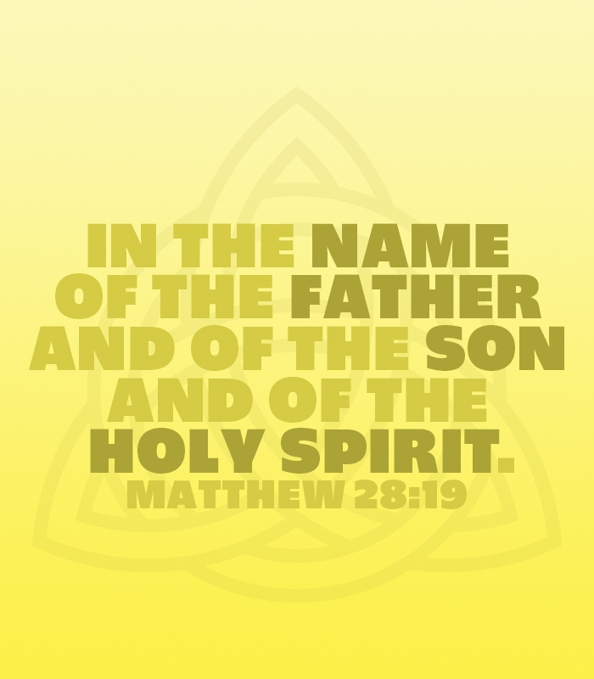

Holy Cross Lutheran Church

Called by the Holy Spirit
to Come
to Grow
to Live
as Disciples of Jesus Christ

