Seventh Sunday of Easter
May 17, 2026

Gathering

Welcome & Announcements
Prelude
Confession and Forgiveness
In the name of the Father, and of the Son, and of the Holy Spirit.
Amen.
Almighty God, to whom all hearts are open, all desires known, and from whom no secrets are hid: Cleanse the thoughts of our hearts by the inspiration of your Holy Spirit, that we may perfectly love you and worthily magnify your holy name, through Jesus Christ our Lord.
Amen
If we say we have no sin… cleanse us from all unrighteousness.
Most merciful God,
We confess that we are slaves to sin and cannot free ourselves. We have sinned against you in thought, word, and deed, by what we have done and by what we have left undone. On account of your great mercy, through your Son Jesus Christ, we pray that you would free us from ourselves, so that we may trust in your promise and obey your commandments, to the glory of your holy name. Amen.
Absolution -
Almighty God in His mercy…… In the Name of the Father, Son and Holy Spirit. Amen.
Gathering Hymn The Church’s One Foundation ELW #654
L: The grace of our Lord Jesus Christ, the love of God, and the communion of the Holy Spirit be with you all.
C: And also with you.
L: Sing to God, sing praises to his name; lift up a song to him who rides upon the clouds
C: his name is the LORD be exultant before him.
L: Father of orphans and protector of widows
C: is God in his holy habitation.
L: God gives the desolate a home to live in;
C: he leads out the prisoners to prosperity, but the rebellious live in a parched land.

Psalm 68:4-5

Praise Hymn Crown Him with Many Crowns ELW #855

Greeting and Prayer of the Day
O King of Glory and Lord of countless angels,
in triumph you ascended to the highest heaven. Abandon us not to be orphans, but keep your Father's promise to send your Spirit of truth. You live and reign with the Father and the Holy Spirit, one God, now and forever. Amen.
Word
First Reading Acts 1:12-25 NT p. 122-123
Second Reading 1 Peter 4:12-19; 5:6-11 NT p. 253-254
Gospel Verse Lift High the Cross ELW #660 vs.1
Gospel John 17:1-11 NT p. 115
Chidren’s Time
Sermon New Life Principles: Share the Glory

Hymn of the Day Lord, You Give the Great Commission ELW #579

Prayers L: God of grace. All: Hear our prayer.

Sharing of the Peace
The peace of Christ be with you always! And also with you.

Meal
Gathering of Offerings (including change for Guatemalan Girls School)

Offertory Hymn Lord, Whose Love in Humble Service ELW #712 vs. 1

Offertory Prayer
P: Let us pray. Merciful Father,
C: we offer with joy and thanksgiving what you have first
given us—our selves, our time, and our possessions, signs of
your gracious love. Receive them for the sake of him who
offered himself for us, Jesus Christ our Lord. Amen
Words of Institution
Lord’s Prayer
Distribution — All are welcome! We will commune by tables around the altar. For those who prefer, gluten-free wafers and grape juice are offered. Children are invited to come forward to receive a blessing.
Post Communion Prayer
Sending
Benediction
Sending Hymn Blest Are They ELW #728
Dismissal Go in peace. Christ is near. All: Thanks be to God!
Preacher: Pastor Carl Billings
Musician: Carol Kelm
Ushers: Tom & Nancy Stack
Altar Guild: Gloria Hill
This Week at Holy Cross
Today 9:00 am — Worship
10:10 am — Fellowship (Mary Ann Ross Serving)

Monday 11:00 am — Bible Study at Havenwood
Noon-6:00 pm — Bloodmobile hosted by Holy Cross

Wednesday 1:30 pm — WOW Bingo at Glenhaven
NEWSLETTER ARTICLE DEADLINE

Thursday 11-Noon —StCroix Valley Food Truck in back Parking lot

Friday 9:30 am — Friday Morning Coffee

Next Sunday,
May 24th 9:00 am — Worship
10:10 am — Fellowship (Altar Guild Serving)

Ceiba Vida International-Guatemalan Girls School – Change Offering — Our mission is to provide young girls an excellent and challenging educational experience modeling Christ’s love.

Community VBS —This year’s Vacation Bible School will be
July 27-30, 6 pm to 8 pm hosted by Holy Cross. We are thrilled to welcome Immanuel Lutheran Church in addition to long- time friend St. John the Baptist Catholic Church. Our theme is True North!
Sharing and showcasing Jesus as their unwavering guide to life.
Many hands will be needed to make this all happen.

Fair Stand – St Croix County Fair July 15 – 19, will be here before we know it! Watch for details on how you can help .
Work a shift or two / Bake pies or bars / Donate.

Prayer Request/Connection Card—Please find new green Connection Card/Prayer Request cards in the pews in front of the bibles. Please fill out as needed and place in collection plate.
Offering Counters Needed – We are in need of volunteer offering counters. Please contact the church office or Joan Bartz.

Pastor Carl Billings in Glenwood City –
Tuesday– Afternoon – evening, & Wednesday all day

Thursday – Morning, Sunday – Morning
GIVING with VANCO
Wanda will be in the office – Monday-Thursday 9-3 or so…

Holy Cross Lutheran Church
615 Maple Street, PO Box 65, Glenwood City, WI 54013
(715) 265-4411 gcHolyCross@cltcomm.net gcholycross.org
Intentional Interim Pastor Carl Billings
Phone: (763) 360-7126 Email: carlbillings@me.com

May 17, 2026
Fifth Sunday of Easter

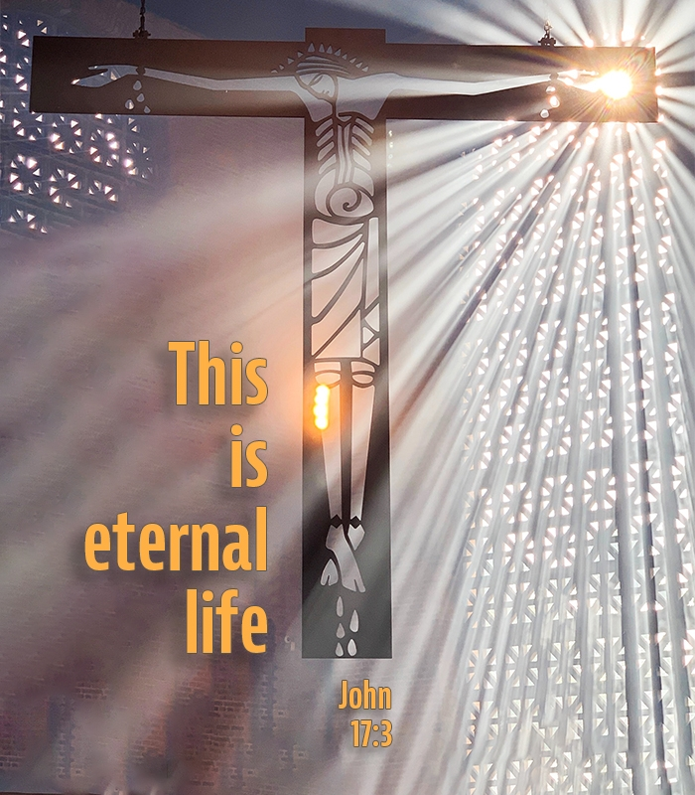

Holy Cross Lutheran Church

Called by the Holy Spirit
to Come
to Grow
to Live
as Disciples of Jesus Christ

