Nineteenth Sunday after Pentecost
October 4, 2026
Gathering
Welcome & Announcements
Prelude
Confession and Forgiveness
In the name of the Father, and of the Son, and of the Holy Spirit.
Amen.
Almighty God, to whom all hearts are open, all desires known, and from whom no secrets are hid: Cleanse the… through Jesus Christ our Lord.
Amen
If we say we have no sin… cleanse us from all unrighteousness.
Most merciful God,
We confess that we are slaves to sin and cannot free ourselves. We have sinned against you in thought, word, and deed, by what we have done and by what we have left undone. On account of your great mercy, through your Son Jesus Christ, we pray that you would free us from ourselves, so that we may trust in your promise and obey your commandments, to the glory of your holy name. Amen.
Absolution -
Almighty God in His mercy…… In the Name of the Father, Son and Holy Spirit. Amen.
Gathering Hymn My Hope Is Built on Nothing Less ELW #596
L: The grace of our Lord Jesus Christ, the love of God, and the communion of the Holy Spirit be with you all.
C: And also with you.
Kyrie ELW p. 138
L: In peace, let us pray to the Lord
C: Lord, have mercy.
L: For the peace from above, and for salvation, let us pray to the Lord.
C: Lord, have mercy.
L: For the peace of the whole world, for the well-being of the Church of God, and for the unity of all, let u pray to the lord.
C: Lord, have mercy.
L: For the holy house, and for all who offer here their worship and praise, let us pray to the lord.
C: Lord, have mercy.
L: Help, save, comfort and defend us, gracious Lord. C: Amen

Psalm 80:7-19
Praise Hymn Children of the Heavenly Father ELW # 781

Greeting and Prayer of the Day
Generously pardon and give peace to your faithful people,
O Lord, that being cleansed from every sin, we may be free and glad to serve; through Jesus Christ, your Son, our Lord, who lives and reigns with you and the Holy Spirit, one God, now and forever. Amen
Word
First Reading Isaiah 5:1-7 OT p. 702-703
Second Reading Philippians 3:4b-14 NT p. 211
Gospel Verse Halle, Halle, Hallelujah ELW #172
Gospel Matthew 21:33-46 NT p. 16
Chidren’s Time
Sermon Keep it Simple Saint: Foundational
Hymn of the Day There in God’s Garden ELW #342
Prayers L: God of grace. All: Hear our prayer.
Sharing of the Peace
The peace of Christ be with you always! And also with you.
Meal
Gathering of Offerings (including change for our mission church)
Offertory Hymn Lord, Let My Heart Be Good Soil ELW #512
Offertory Prayer
P: Let us pray. Merciful Father,
C: we offer with joy and thanksgiving what you have first
given us—our selves, our time, and our possessions, signs of
your gracious love. Receive them for the sake of him who
offered himself for us, Jesus Christ our Lord. Amen
Words of Institution
Lord’s Prayer
Distribution — All are welcome! We will commune by tables around the altar. For those who prefer, gluten-free wafers and grape juice are offered. Children are invited to come forward to receive a blessing.
Post Communion Prayer
Let us pray…We give you thanks, almighty God, that you have refreshed us through the healing power of this gift of life; and we pray that in your mercy you would strengthen us, through this gift, in faith toward you and in fervent love toward one another; for the sake of Jesus Christ our Lord. Amen
Sending
Benediction
Sending Hymn We Walk by Faith ELW #635
Dismissal Go in peace. Christ is near. All: Thanks be to God!
Preacher: Pastor Carl Billings
Musician: Carol Kelm
Ushers: Mastbergen Family Acolyte: Deelia Hoffman
Altar Guild: Gloria Hill & April Goodwin SS Teacher: April Goodwin
This Week at Holy Cross
Today 9:00 am — Worship
10:10 am — Fellowship (Council Serving)

Monday 11:00 am — Bible Study at Havenwood
6:00 pm — Faith & Life / FUN Meeting

Wednesday 5:30 pm — Confirmation Meal
6:00 pm — Confirmation Class
6:45 pm — Mid Week Worship

Friday 9:30 am — Friday Morning Coffee

Saturday 7:30-4:30 pm – Building Rental – Marigold Quilt Class

Next Sunday,
October 11th 9:00 am — Worship
10:10 am — Fellowship (WOW Serving)

Feed My Starving Children – Service Event
Wednesday October 14 @3:00 pm. See kiosk for details

Annual Fall Supper – Wednesday October 21st 4:30-7:00 pm
Come and enjoy all your Fall Supper favorites and time of fellowship.

Confirmation Sunday – Sunday October 25th at 9:00 am.

Sunday School has begun – Any child 4K-5th Grade is welcome to join. Children will be excused after “Children’s Time” during worship to attend Sunday School. Sign up for Teachers and Classroom Helpers is on the bulletin board in the Fellowship Hall.

Blood Mobile – Monday October 12th the Blood Mobile will be at Holy Cross. Sponsored by St John’s.
Sign up to donate blood at www.redcrossblood.org.

Pastor Carl Billings in Glenwood City –
Tuesday– Afternoon – evening, & Wednesday all day

Thursday – Morning, Sunday – Morning
GIVING with VANCO
Wanda will be in the office – Monday-Wednesday 9-3 or so…

Holy Cross Lutheran Church
615 Maple Street, PO Box 65, Glenwood City, WI 54013
(715) 265-4411 gcHolyCross@cltcomm.net gcholycross.org
Intentional Interim Pastor Carl Billings
Phone: (763) 360-7126 Email: carlbillings@me.com

October 4, 2026
Nineteenth Sunday after Pentecost

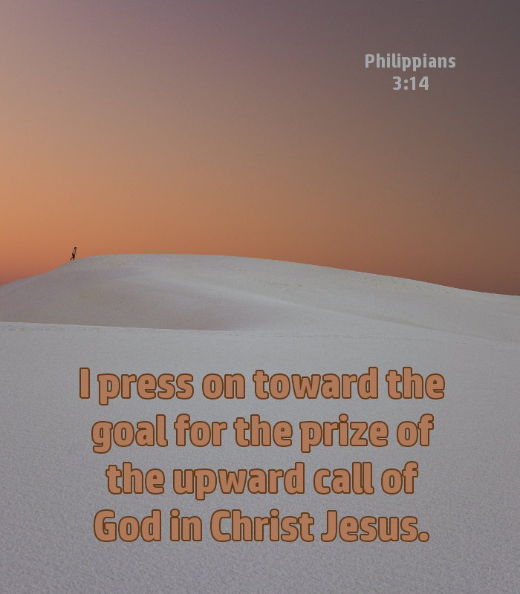

Holy Cross Lutheran Church

Called by the Holy Spirit
to Come
to Grow
to Live
as Disciples of Jesus Christ

