Reformation Sunday
October 25, 2026

Gathering

Welcome & Announcements

Confession and Forgiveness
In the name of the Father, and of the Son, and of the Holy Spirit.
Amen.
Almighty God, to whom all hearts are open, all desires known, and from whom no secrets are hid: Cleanse the… through Jesus Christ our Lord.
Amen
If we say we have no sin… cleanse us from all unrighteousness.
Most merciful God,
We confess that we are slaves to sin and cannot free ourselves. We have sinned against you in thought, word, and deed, by what we have done and by what we have left undone. On account of your great mercy, through your Son Jesus Christ, we pray that you would free us from ourselves, so that we may trust in your promise and obey your commandments, to the glory of your holy name. Amen.
Absolution -
Almighty God in His mercy…… In the Name of the Father, Son and Holy Spirit. Amen.

Gathering Song Awesome God W & P # 13

L: The grace of our Lord Jesus Christ, the love of God, and the communion of the Holy Spirit be with you all.
C: And also with you.
Kyrie ELW p. 138
L: In peace, let us pray to the Lord
C: Lord, have mercy.
L: For the peace from above, and for salvation, let us pray to the Lord.
C: Lord, have mercy.
L: For the peace of the whole world, for the well-being of the Church of God, and for the unity of all, let u pray to the lord.
C: Lord, have mercy.
L: For the holy house, and for all who offer here their worship and praise, let us pray to the lord.
C: Lord, have mercy.
L: Help, save, comfort and defend us, gracious Lord. C: Amen

Praise Song By grace we have been saved W & P #25

Greeting and Prayer of the Day
O Lord God,
heavenly Father, pour out your Holy Spirit upon your faithful people. Keep them steadfast in your grace and truth, protect and comfort them in all temptation, defend them against all enemies of your Word, and bestow upon the Church your saving peace; through your Son, Jesus Christ, our Lord, who lives and reigns with you and the Holy Spirit, one God, now and forever. Amen
Word
Children’s Time
First Reading Revelation 14:6-7 NT p. 276
Second Reading Romans 3:19-28 NT p.160-161
Gospel Verse Thy word W & P #144
Gospel John 8:31-36 NT p. 105
Sermon Word Power

Song of the Day Lord, my strength W & P #93

Confirmation See Booklet

Prayers L: God of grace. All: Hear our prayer.

Sharing of the Peace
The peace of Christ be with you always! And also with you.

Meal
Gathering of Offerings (including change for our mission church)

Offertory Song Cares chorus W & P #27

Offertory Prayer
P: Let us pray. Merciful Father,
C: we offer with joy and thanksgiving what you have first given us—our selves, our time, and our possessions, signs of your gracious love. Receive them for the sake of him who offered himself for us, Jesus Christ our Lord. Amen
Words of Institution
Lord’s Prayer
Distribution — All are welcome! We will commune by tables around the altar. For those who prefer, gluten-free wafers and grape juice are offered. Children are invited to come forward to receive a blessing.
Post Communion Prayer
Let us pray…We give you thanks, almighty God, that you have refreshed us through the healing power of this gift of life; and we pray that in your mercy you would strengthen us, through this gift, in faith toward you and in fervent love toward one another; for the sake of Jesus Christ our Lord. Amen
Sending
Benediction
Sending Hymn May you run and not be weary W & P #97
Dismissal Go in peace. Live by the Spirit All: Thanks be to God!
Preacher: Pastor Carl Billings
Musicians: Carol Kelm, Bruce Kelm & John Lindelof
Ushers: Mastbergen Family
Altar Guild: April Goodwin & Gloria Hill SS Teacher: Barb Eliason
This Week at Holy Cross
Today 9:00 am — Worship / Sunday School
Confirmation Sunday
10:10 am — Fellowship (Altar Guild Serving)

Monday 11:00 am — Bible Study at Havenwood

Wednesday 5:30 pm — Confirmation Meal
6:00 pm — Confirmation Class
6:45 pm — Mid Week Worship

Friday 9:30 am — Friday Morning Coffee

Next Sunday,
November 1st 9:00 am — Worship – Sunday School
All Saints Sunday
10:10 am — Congregational Meeting
10:10 am — Fellowship (Council Serving)

Sunday School Teachers Needed – Sign up sheets are on the bulletin board in the Fellowship Hall. We have several openings for both teachers and helpers in November and December.

Veterans Appreciation Dinner/Program – On Sunday November 8th our Confirmation Students, their Mentors & Parents, and HS Youth will be a dinner and a short program.
Please contact Jill Logghe or the church office.

All Saints Sunday – Next Sunday November 2nd we will remember those who have passed in the last year during our worship service.

Prayer Request/Connection Card—Please find new green Connection Card/Prayer Request cards in the pews in front of the bibles. Please fill out as needed and place in collection plate.

Pastor Carl Billings in Glenwood City –

Tuesday– Afternoon – evening, & Wednesday all day
GIVING with
VANCO
Thursday – Morning, Sunday – Morning
Wanda will be in the office Monday & Tuesday 9-3 and Wednesday 9-noon
Church office will be CLOSED the rest of the week.

Holy Cross Lutheran Church
615 Maple Street, PO Box 65, Glenwood City, WI 54013
(715) 265-4411 gcHolyCross@cltcomm.net gcholycross.org
Intentional Interim Pastor Carl Billings
Phone: (763) 360-7126 Email: carlbillings@me.com

Confirmation Sunday
October 25, 2026
Reformation Sunday
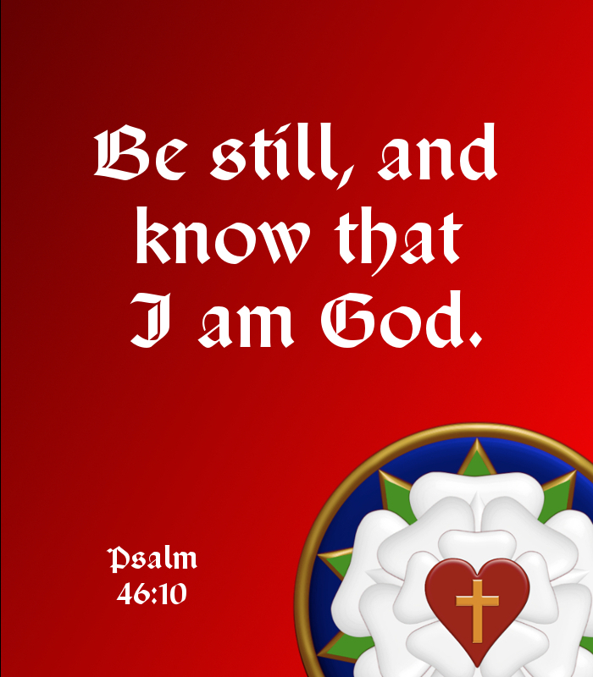

Holy Cross Lutheran Church

Called by the Holy Spirit
to Come
to Grow
to Live
as Disciples of Jesus Christ

